

**Database Management Project**

Report 02

**Group 01**

|  |  |
| --- | --- |
| **Name :** | **ID:** |
| Udipta Mazumder | 1710138 |
| Tamima Sigma | 1630436 |
| Hasan Ahmed | 1610266 |
| Misbah Ahmed | 1510998 |
| Md. Mahmud Hassan Rabby | 1731609 |
| Md Rakib Hossain | 1731400 |
| Rakibul Hasan Rajib | 1921834 |

**SPMS2.0(Updated)**

**Contents**

**CHAPTER 1 - INTRODUCTION:** 2

**A. BACKGROUND OF THE ORGANIZATION- IUB:** 3

**B. BACKGROUND OF THE PROJECT SPSM 2.0:** 5

**C. OBJECTIVE OF THE PROJECT SPSM 2.0:** 5

**D. SCOPE OF THE PROJECT:** 6

**CHAPTER 2 - REQUIREMENT ANALYSIS:** 7

**A. RICH PICTURE – EXISTING BUSINESS SYSTEM:** 8

**B. SIX ELEMENTS ANALYSIS - EXISTING BUSINESS SYSTEM:** 10

**C. PROCESS MODEL – EXISTING BUSINESS SYSTEM:** 17

**D. PROBLEM ANALYSIS – EXISTING BUSINESS SYSTEM:** 20

**E. RICH PICTURE - PROPOSED SYSTEM:** 22

**G. PROCESS MODEL - PROPOSED SYSTEM:** 28

**CHAPTER – 3 LOGICAL SYSTEM DESIGN** 31

**A. BUSINESS RULE [ SPM V2.0 ]:** 31

**B. ENTITY RELATIONSHIP DIAGRAM:** 33

**C. ENTITY RELATIONSHIP DIAGRAM TO RELATIONAL SCHEMA:** 34

**D. NORMALIZATION:** 35

**E. DATA DICTIONARY:** 39

# 

# **CHAPTER 1 - INTRODUCTION:**

The Independent University Bangladesh (IUB) has robust and versatile schools - notably consisting of following:

● Business & Entrepreneurship

● Engineering, Technology & Sciences

● Environment and Life Sciences

● Liberal Arts & Social Sciences

● Pharmacy and Public Health.

The university has been an active participant in the growth of the education sector in Bangladesh and produced capable and knowledgeable scholars contributing both here and abroad. [1]

IUB has achieved this through working closely with relevant government education institutions and organizations such as the University Grants Commission (UGC), Ministry of Education, and other necessary institutes for each of the schools, regularly updating its curriculums and putting in a system to monitor student performance based on a quantified approach between course curriculum and standards set by UGC and the Bangladesh government and constantly tracking student performance for every semester – mainly, using Outcome-Based Education (OBE) for monitoring performance and setting university curriculum. [1]

The focus of this report is to study the current student performance monitoring system that IUB uses, do the required analysis of its processes, and propose a new and better improved system that reduces error, makes analysis of data and report generation easier by all vested quarters and produce/show valuable information needed for IUB and its collaborators in making necessary improvements in academia to produce better scholars. The first part focuses on the details of the organization in question and the project that we have undertaken for it. The second part focuses on the existing system and its shortcomings and an introduction of the proposed system that we plan to replace the existing system with. The third and fourth will be heavily technical and focus on how we plan to bring the proposed system into being.

During our research into the existing system for student performance monitoring we have found many areas where valuable changes could be made to make each process of monitoring student performance faster, make communication between necessary stakeholders easier, take away chances for errors and data duplication, and most importantly make it easier for all stakeholders to easily surf through large datasets to get meaningful information to their requirement.

As we go through this report, we will dig deeper into how the current student performance monitoring system operates, the business processes involved, where there are concerns and issues related to data management, and how we can make a better system to address these issues for fixing and improvement.

## **A. BACKGROUND OF THE ORGANIZATION- IUB:**

Independent University – Bangladesh (IUB), established in 1993, is one of the oldest private universities in Bangladesh, currently has more than an estimation of 7,048 undergraduate and graduate students and over 10,455 alumni. This student population is mostly predicted to grow at 10% annually. [2]

IUB, over-time, has shown remarkable outcomes in producing graduates with marketable skills only because of staying disciplined and up to date with the on-going curriculum and progress system. Dedicating attention towards IUB’s Departments, and more specifically focusing the Department of Computer Science and Electrical science into a well-funded research hub running several research projects. IUB is also committed to curve potential graduates of international standard who are mainly equipped to provide new leadership to the national economy through skilled employment, entrepreneurship and/or applied research. This is successful due to the overwhelming support of the Bangladesh Government and the UGC for IUB to be able to create state-of-the-art lab facilities in their department. It is because of IUB’s approach to academics as an “Application Oriented Learning” philosophy that “not only teaches students the fundamental principles of learning, situation -handling, and have better overall perception by providing them with hands-on training sessions.” [3]

Continuously growing it’s lab facilities and flourishing on its curriculum according to current market economic demands, the SECS and the Department of Computer Science and Engineering at IUB has constantly worked with IEB, UGC and the Ministry of Education to track their students’ overall performance under specific periods by quantifying specific courses and its relating assessments into measurable trackers to gain valuable insights for improvement of students over the years as a student in a certain department.

These processes and criteria credentials courses are ultimately set by IEB along with relevant government potentials to set the bar for up-coming graduating engineers from top universities in Bangladesh. These set of standards come in the form of Program Educational Objectives (PEO) and Program Learning Outcomes (PLO) [1] for specific departments in an Accreditation Manual which are mapped to specific courses by relevant Course Instructors and Co-Ordinator’s. This allows the Department of CSE at IUB, SECS, IEB and all other relevant stakeholders to have a calculating assessment of the current state-of-affairs and the performance of each student under each course for every semester. This will also allow users to track performance of faculties, courses, departments and schools and provides valuable insight for making necessary improvements.

## **B. BACKGROUND OF THE PROJECT SPSM 2.0:**

Measuring the output of students, faculties, departments, and their respective courses in order to measure their productivity in regard to the outcome relevance of the course activities. Basically, to provide a range of tools and data intended to help universities and education authorities such as IEB, UGC, as well as other stakeholders to evaluate the performance of students and inform strategies for improvements. Developing a national framework for Outcome-Based Education while at the same time leaving considerable freedom to universities in implementing local approaches.

## **C. OBJECTIVE OF THE PROJECT SPSM 2.0:**

The SPMS 2.0 system monitors and summarizes the performances of the stakeholders - students, faculties, schools, and departments through the database of the assessments. For evaluation purposes the system would be able to store individual assessment marks (midterm, quizzes, assignment, projects, presentations and so on). As well as the marks of those assessments with respect to their Course Outcomes (CO) and Program Learning Outcomes (PLO) accordingly in the database of the system to observe the outcome and performance of the student’s faculties, schools, and departments. SDASDASDSDAADASDASDASDADDA

The students being the primary stakeholder, would be able to statistically directly monitor the overall performance to their satisfaction of certain course objectives. Hence based on their performances and faculty evaluation the higher stakeholders (Head of department and Admin) can understand and manage the degree in comparison to which different course outcomes targets and their achievements are being understood by the student, department, school, and university body as a whole. SPSMS 2.0 also monitors the impact of policies against overall administrative goals and targets by the system. The system’s main target is to monitor the whole university activities through the database and produce analytics for the Head of Department, Faculty, School, Students, and their Courses in a given period of time (yearly and semester wise).

## **D. SCOPE OF THE PROJECT:**

We did a complete analysis of the existing system and found out places in the business processes which can cause severe lapses in time and communication, which we will discuss in the next chapter.

Our solution is to create a Web application, called SPMS 2.0 (Student Performance Monitoring System 2.0), using a Relational Database Management System (RDMS) to store, edit, add, and update necessary data for monitoring student performance and producing and storing related OBE data, reports, and documents.

We produced potential users for the web based SPMS 2.0 system and speculated how they would be using the system and the necessary information and data they would need access to. Since the problems can arise from many points of all business processes, we will make custom user interfaces and login capabilities for all stakeholders who will also be the users of this system.

Since we use a (RDBMS) for data storage, retrieving necessary files, tabular data, page layouts and reports becomes incredibly easy and allows us to interact with the necessary data to occur real-time. We also create interfaces for all users to easily access these data and use them to generate and download reports.

We build an interface for faculties to be able to collaborate with each other on developing course outlines,coursereports, marksheets, assessments, mapping assessments to CO’s and PLOs for PLO achievements, and record assessments of students throughout the semester for all their courses.

Students, the IUB leadership team and government agencies can also access the systems for drawing conclusions. Data will also be protected, and each stakeholder will be shown only that data which is relevant to them, respectively.

# **CHAPTER 2 - REQUIREMENT ANALYSIS:**

The Requirement Analysis is the means of using industry tools, methods, and standards, to research and visualize the current system and the processes that go into the business operation of a certain organization. “Requirements Analysis is the process of determining what the database is to be used for. It involves interviews with user groups and other stakeholders to identify what functionality they require from the database, what kinds of data they wish to process and the most frequently performed operations.” [4]

By doing this we can see each stakeholder and how they interact with each other. We use simple notations and symbols to give anyone the idea of how a business process works and dissect it accordingly.

As we will see, this process of analyzing lets us find out apparent and not so apparent problems with an existing system of monitoring student performance that is manual and depends on involving third party actors and stakeholders causing errors in the system.

## **A. RICH PICTURE – EXISTING BUSINESS SYSTEM:**

A Rich Picture is a way to explore, acknowledge and define a business process and express it through diagrams to create a preliminary mental model. A rich picture helps to open discussion and come to a broad, shared understanding of a situation. [5]The finished rich picture could be of value to other stakeholders of the problems in an existing system, but also allows them to capture many different facets of the situation. Rich pictures concentrate on both the structure and the processes of a given situation. [6]

The Rich Picture Analysis also takes in to account the following:

· Structures

· Processes

· Climate

· People

· Issues expressed by people

· Conflict

As we can see, this rich picture was prepared keeping exactly those things in mind.

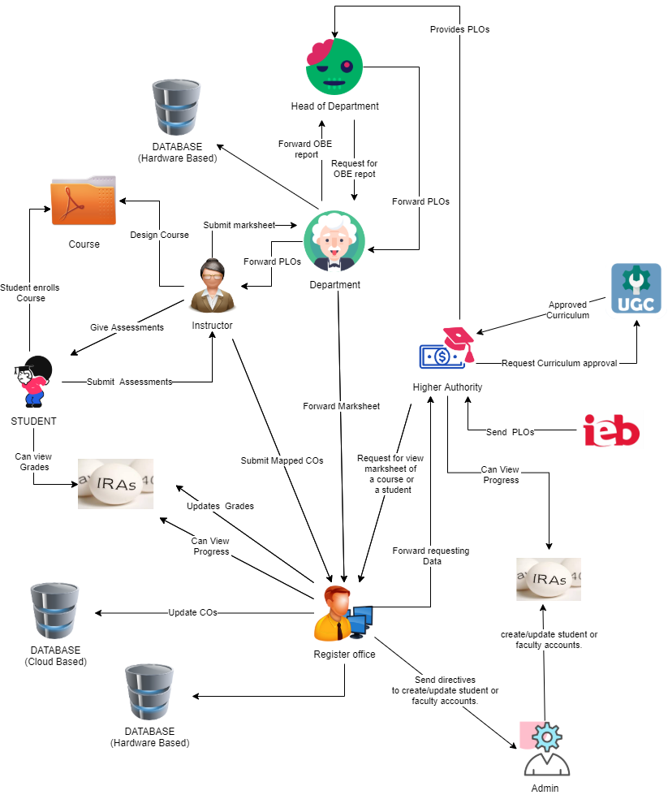

Figure 1.0 : Rich Picture of Existing System to Monitor SPMS.

**The Rich Picture Analysis shows us that we have the following types of stakeholders:**

1. IEB/UGC/Ministry of Education

2. VC/Board of Trustees

3. Head of Department/Dean of School

4. Department (working under Head of Department/Dean of School)

5. Faculty/Course Coordinators

6. Registrar’s Office

7. Admin (working under Registrar’s Office)

8. Students

**We can also identify three separate storage systems or facilities, namely:**

1. The Department Storage

2. The Registrar’s Office Storage

3. IRAS

**From this Rich Picture we have drawn out 7 process that are key to monitoring student performance and improving curriculum. The processes are as follows:**

1. Map Course Outcomes (COs) to Program Learning Outcomes (PLOs).

2. Record Student Assessment Data.

3. View Assessment Reports over a given time-period for inspection and analysis of student performance trend.

4. Produce OBE Marksheet & Course Assessment Report.

5. Create student/faculty account and enter/customize necessary data.

6. View Records OBE Marksheets, Course

7. Request for review and change of grades.

## **B. SIX ELEMENTS ANALYSIS - EXISTING BUSINESS SYSTEM:**

The Six Elements Analysis provides a detailed description of the role of each element in each process. It is clear from the table below that Human entities dominate all key functions of this system (especially in the most critical two processes- mapping course outcomes and viewing document related to them.) For example, the current system is heavily dependent on manually processed and handled hardcopy databases. Thus, there is a significantly long chain of waiting between interdependent procedures before the Human elements can fulfill their end of the bargain in the process.

|  |  |  |  |  |  |  |
| --- | --- | --- | --- | --- | --- | --- |
| **Pross** | **System Roles** | | | | | |
| **Human** | **Non-**  **computing Hardware** | **Computing Hardware** | **Software** | **Database** | **Communication/**  **Network** |
| **Design curriculum** | **Instructor**  **a**) Set question  papers for  examinations  according to  mapped COs.  b) Invigilate  examinations  and collect assessment.  c) Develop course materials  d) Assess optimum mapping COs to PLOs  e) Send CO’s to the Registrar's office for records progress.  f) Provides mark sheet to the department | **Hard copy**  Pen, paper, whiteboard  **Spreadsheets**  A collection of all marks (data) of respective assessments. | **Computer**  a) Used by  faculties to  access the  COs from the  Excel sheet.  b) Faculties  may also use it  to take online  examinations  and interact  with students.  c) Students  may use it to  attend online  Examinations.  **Mobile Phone**  a) Some  examinations  may allow  mobile phones  for scanning  and uploading  pdfs to virtual  Examinations.  **Printer**  a) Used by  faculties to  print out  question  papers for  Students.  **Networking**  **devices**  (Router,  Switch,  Bridge, Hub) | **Microsoft**  **Office**  **a)** The software  from which the  faculty will  collect COs.  Google  **Classroom**  **a) Used by**  **fa**culties and  students during  Examinations.  **Operating**  **System**  **a)** Any OS used  by the users,  e.g. Windows,  Mac.  Printing  Software  **PDF viewer**  **a**) To view  questions in  PDF or send  the answer in PDF | **Microsoft**  **Excel**  **Database**  a) Faculty  access COs  from this. | **Email**  **a)** Written discussion between stakeholders, designers, faculty, and higher management.  b) Share draft documents between each other.  **WiFi**  **a)** Used for connectivity between users and the existing system while at the university.  **Internet**  **a)** Used for connectivity between users and the existing system while away from the university. |
| **Student Assessment** | **Student :**  a) Attend  examinations  and submit  attempted assessments to faculty via physical or digital methods by deadline.  **Faculty**  a)Provides assessments to the respective students. | **Classroom :**  **a**) At present classes are taken in classrooms properly. | **Computer/**  **Laptop :**  Used by respective faculties and students in the lab to attend classes and lectures to their respective courses.  Projector :  For class lectures, quizzes, presentations and so on.  Speakers :  For auditoriums, lectures and conducting examinations. | **Microsoft Word/Excel**  **a)** Used to keep student’s assessment marks and grades. For example mid-term paper, quiz, finals etc.  Operating  System :  a) Any OS used  by the users,  e.g. Windows,  Mac, Ubuntu. | **Microsoft**  **Excel**  **Database**  a) Faculty  Evaluate and create a report of COs as per student’s assessment. |  |
| **Performance based Quality Assurance** | **Higher Management :**  **a**) Monitoring student performance  b) Obtain course marksheets from faculty and student attendance data from attendance system (IRAS)  c) Identify performances of the students  d)Identify quality performances of faculty  e) Monitoring faculty performance  f) Collect faculty evaluations during the evaluation period from students. | **Spreadsheet**  **a)** Used to keep student’s assessments. For example mid term paper, quiz,finals etc.  Assessment scripts  a) Used to evaluate students and faculty evaluation  Pen and paper :  a) Used by faculty and higher management to brainstorm and design course content. | **Computer**  a) Used by  Higher managements to  access the  COs from the  Excel sheet.  b) Faculties  may also use it  to collect and evaluate assessments..  c) Students  may use it to  evaluate faculty.  Photocopy machines  a) Accumulating progresses per time period in hardcopies for offline storage and tracking. | **Operating**  **System :**  **a)** Any OS used  by the users,  e.g. Windows,  Mac, Ubuntu. |  |  |
| **Accounts management** | **Admin:**  Creates/edits student accounts when enrolled  **Student:**  Enrolls into a program and their respective courses.  **Faculty:**  A course is assigned to them according to their sections. | **Pen and paper**  **a**) Used by the Registrar's office providing forms in hard copies. | **Computer**  a) Used by  Registrar's office and admin to  access the  COs from the  Excel sheet.  b) Faculties  may also use to assign their respective course sections as per semesters wi**se.** | **Operating**  **System :**  **a)** Any OS used  by the users,  e.g. Windows,  Mac, Ubuntu. | **Microsoft Word/Excel**  **a)** Used to keep student’s assessment marks and grades. For example mid-term paper, quiz, finals etc. | **Email**  **a**) Written discussion between stakeholders, designers, faculty, and higher management.  b) Store documents in IRAS.  **WiFi:**  **a)** Used for connectivity between users and the existing system while at the university.  **Internet**  **a)** Used for connectivity between users and the existing system via LAN network connections. |
| **UGC based regulations** | **Higher**  **Management**  **(HM)**  a) Sends the  Curriculum  booklet  to UGC.  b) If it gets  approved by  the UGC then  the HM  publishes the  Curriculum  booklet.  c) If it doesn’t  get approved  the HM sets  the Curriculum  according to  the demands  of the UGC.  d) HM Sends  the Updated  Curriculum to  the  Department.  **UGC:**  **a)** Receives the  Curriculum  booklet from  the HM.  b) Reviews the  booklet if it  requires  changes it  sends back  feedback to  the HM  regarding the  changes as  needed else it  is approved by the UGC. | **Pen, paper and manual book.**  **a)** Used by the UGC to approve along with appropriate documentatio**n.** | **Computer**  **a)**To generate & evaluation as per the university curriculum design.  **Mobile Phones**  a)To communicate on the net and keep updates. | **Operating**  **System :**  **a)** Any OS used  by the users,  e.g. Windows,  Mac, Ubuntu, Android. |  | **Email**  **a)** Written discussion between stakeholders, Higher Management.  **WiFi**  **a)** Used for connectivity between users and the existing system.  **Internet**  **a)** Used for connectivity between users and the existing system via LAN network connections**.** |

## **C. PROCESS MODEL – EXISTING BUSINESS SYSTEM:**

Business Process Model and Notation (BPMN) is a graphical representation for specifying business processes in a business process model. [7] We use business process model diagrams to dissect each of the business processes mentioned in the previous section.

Each diagram separates the stakeholders involved in the processes, the exchanges among them and the decisions each of them need to make.

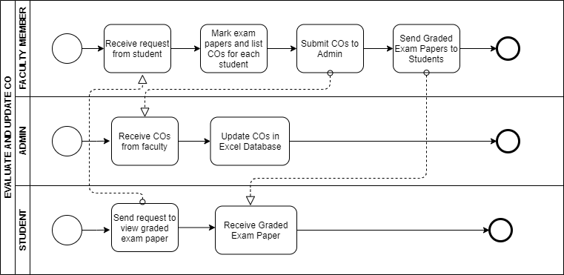

Figure 1.1: Evaluate and update CO

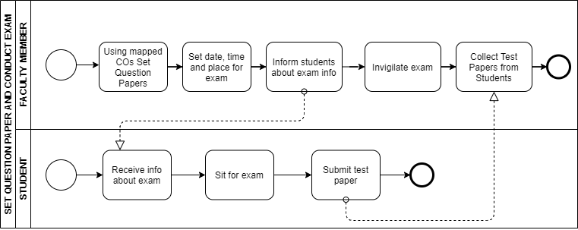

Figure 1.2: Set question paper and conclude exam

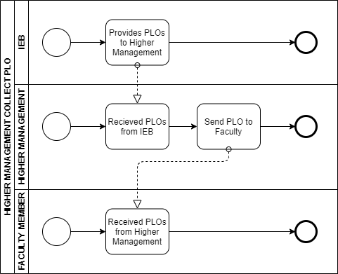

Figure 1.3: Higher management collect PLO

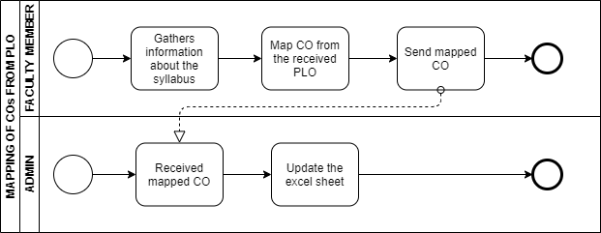

Figure 1.4: Mapping of CO from PLO

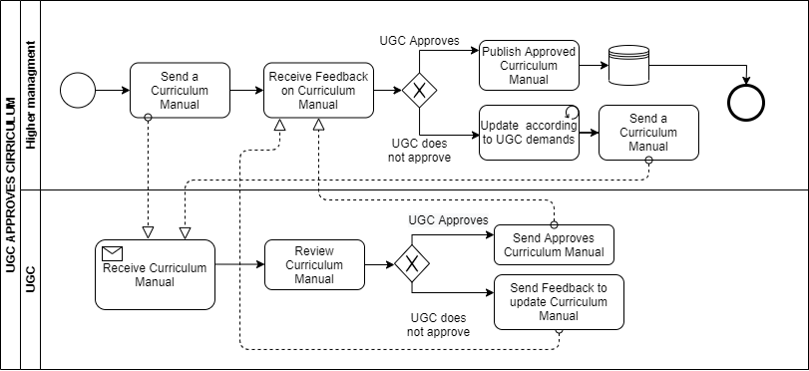

Figure 1.4: UGC approves curriculum

## **D. PROBLEM ANALYSIS – EXISTING BUSINESS SYSTEM:**

Based on the existing systems’ Six Elements Analysis, the shortcomings in each process were identified. There is a repeating pattern in the far-right column of this table. It appears that the facilitation of a private online platform will improve the system in many ways.

|  |  |  |  |  |
| --- | --- | --- | --- | --- |
| **Process Name** | **Stakeholders** | **Concerns(Problems)** | **Analysis (Reason of the Problems)** | **Proposed Solution** |
| **Student Enrollment** | 1.Student  2. Registrar Office  3. Department Head | 1. School-wise, department-wise and program-wise student enrollment comparison. | Student enrollment and other information are not counted in the system. | We want to keep the in the count of students enrolled school-wise, department-wise and program-wise and make it transparent semester-wise |
| **Performance trend according to GPA and CGPA** | 1.Student  2.Teachers  3.Department-Head  4. VC | 1. School-wise, department-wise and program-wise student performance trends based on CGPA with respect to a given period of time/semesters.  2. Course-wise (for a selection of courses) student performance trend based on GPA with respect to a given period of time/semesters. | GPA and CGPA need to be calculated by the teachers manually. | We want keep the data and create a graph of GPA and CGPA and it gets easier to evaluate and analyze in a glance |
| **PLO and CO achieved and attempted** | 1.Student  2.Instructor  3.Department  4.School | 1. Student-wise, Instructor wise department wise, Department, School-wise PLO and CO analysis were absent and transparent. | PLO and CO are not calculated or analyzed | PLO and Co will be calculated and made transparent for analysis and comparison semester wise/time period. |

## 

## **E. RICH PICTURE - PROPOSED SYSTEM:**

The Course Outcomes (COs) and Program Learning Outcomes (PLOs) will be visible in a new system, an online platform called SPMS, where it will have its own database that host the data of all the courses, faculties, as well as updated tables every semester to keep track of which courses have been assigned to which faculties in a given semester. We are making the new system (to track student performance, but also to track faculties teaching a specific course or the performance of students in a course over a period) and why it is hard to track these trends and data right now. Briefly, we can see that the SPMS relational database (a non-human) quite literally plays a significant role in the student performance monitoring system. Also, this entity holds the greatest number of interconnections between all other processes.

We will use different user interfaces designed for specific user needs based on the concerns and problems we found in the problem analysis. The Head of the Department/Dean of School, Course Instructor/Coordinator/Faculty, Admin, Student, IEB/UGC/Ministry of Education, VC/Board of Trustees, Department Staff, all these stakeholders mentioned will have access to view the report of a student.

Figure 1.5: Rich Picture of Proposed System to Monitor Student Performance.

**F. SIX ELEMENTS ANALYSIS - PROPOSED SYSTEM:**

The six elements analysis of the proposed system is a continuation of an analysis process where each analysis is based on the one that comes before it. Based on the rich picture, the role of each element in the new system is further understood in the table below.

|  |  |  |  |  |  |  |
| --- | --- | --- | --- | --- | --- | --- |
| Process | System Roles | | | | | |
| Human | Non-Computing Hardware | Computing Hardware | Software | Database | Network and Communication |
| **Student Enrollment** | **Admin**  **a)** Collect student information from the form.  **b)** Send request to SPMV 2.0  **c)** Admin of SPMV 2.0 crates new account when required  **Developing**  **team and IT**  **Experts**  a) Develop and maintain the SPMV 2.0  **Internet Service Providers (ISP)** a) Provides the Internet service to the data  sources, SPMV 2.0 users and SPMV 2.0 system. |  | **Computer/**  **Laptop**  a) SPMV 2.0 admin will use  computers to access data.   b) Users will use the  computer to view the data.  c) Faculties  will use the  computer to view.  **Database**  **Server**  a) Used by  SPMV 2.0  developers to collect data.  **Networking Devices**  **(Router,**  **Switch,**  **Bridge, Hub):**  a) Used to  access SPM V 2.0. | **Operating**  **Software**  Used by  Registrar Office and SPMV 2.0  **Student**   Uses to fill the form  **SPMV2.0**  The software for which the admin will  create  accounts | **Register Office Database**  Used By the registrar office to collect the student information in a excel file to sent it to SPMV 2.0  **SPMV2.0**  Information is stored in the Database for New user Account or any other updates | **Internet**  a) Its is used to access and store data to SPMV2.0  b) Used to collect the student form from the student to registrar office |
| **Monitor faculty Performance** | **Faculty**  Request for self performance data  **Department Head**  Request for Faculty performance data  **SPMV2.0 Admin**  Receive the request form Faculty and department head and approves |  | **Computers and Laptop**  Faculty and Department head will send request to SPMV2.0 to view performance data  **SPMV2.0**  Will approve the request and provide access to view the data | **Faculty and Department Head**  View Data  **SPMV2.0**  dmin will use to store and update data and provide access to view. | **SPMV2.0**  To access the stored data and sent it to the Faculty and Department Head | **Internet**  a)Its is used by the admin to access and store data to SPMV2.0  b)Faculty use internet to get access to SPMV2.0 cloud |
| **Monitor student performance** | **Faculty**  Request for Assessment report  **Student**  Request for Assessment report    **Department Head**  Request for Assessment report  **Registrar office**  Request for Assessment report  **SPMV2.0 Admin**  Receive the request form Faculty and department head and approves |  | **Computer/**  **Laptop**  a) SPMV 2.0 admin will use  computers to access Data.   b) Users will use the  computer to view the data.  c) Faculties  will use the  computer to view student performance data.  **Database**  **Server**  a) Used by  SPMV 2.0  developers to collect data.  **Networking Devices**  **(Router,**  **Switch,**  **Bridge, Hub):**  a) Used to  access  SPMV 2.0. | **SPMV2.0**  Retrieve data from the database and sent to the desired user. | **SPMV2.0**  To access the stored data and send it to the Faculty, Department head, Registrar office and Student | **Internet**  a)Its is used by the admin to access and store data to SPMV2.0  b)Faculty use internet to get access to SPMV2.0 cloud  c)Department head used internet to get access to the SPMV2.0 cloud  d) SPMV2.0 uses internet to stay connected with its database cloud |
| **Department Performance report** | **Registers Office**  Request for Department performance data  **SPMV2.0 Admin**  Receive the request from department head and register office and approves |  | **Computer/**  **Laptop**  a) SPMV 2.0 admin will use  computers to access Data.   b) Users will use the  computer to view the data.  c) Registers office  will use the  computer to view department performance data.  **Database**  **Server**  a) Used by  SPMV 2.0  developers to collect data.  **Networking Devices**  **(Router,**  **Switch,**  **Bridge, Hub):**  a) Used to  access  SPMV 2.0.  **SPMV2.0**  Will approve the request and provide access to view the data | **Registers office**  View Data  **SPMV2.0**  Admin will use to store and update data and provide access to view. | **SPMV2.0**  To access the stored data and sent it to the Registers office and Department | **Internet**  a)Its is used by the admin to access and store data to SPMV2.0  b) Registers office use internet to get access to SPMV2.0 cloud |
| **Store Assessment Report** | **Student**  Receives Assessment Material, participates and submit in the assessment the student is provided.  **Instructor**  Generates Assessment material , Provides them and receives to mark according to PLO and Cos to submit them .  **Department Head**  Receives  Marksheet to compile and format them and send them to Registrar office.  **Registrar Office**  Overviews approval of formatting and send it to SMPV 2.0  **S**  **PMV 2.0 Admin**  Receives the Marksheet and uploads it to database and send notification to the user |  | **Computer/Laptops  a)**Used by Instructor to generate and receive Assessment Material.  b) Used by Students to receive Assessment Material and submit after participating. c) Used by Department Head to receive the Marksheet, to compile and format them and send them to Registrar office. c) Registrar Office uses Computer to overview the approval **d)** SPMV 2.0 AdminUses to Store it in the database and send notification | **SPMV 2.0**  Uses the Software to access database and store the marksheet | **SPMV 2.0**  Uses the Database to update or upload the Marksheet | **Internet**  a)Its is used by the admin to access and store data to SPMV2.0  b)Faculty use internet to provide assessment material, receive materials from the participants and send the mark sheet.  c) Department head used internet to receive the Mark Sheet and send the formatted ones  d) Registrar Office uses Internet  to send the marksheet to SPMV 2.0  d) SPMV2.0 uses internet to upload and update the database. |

## 

## **G. PROCESS MODEL - PROPOSED SYSTEM:**

After understanding the role of each element in each process, the Business process model and notation provides an unambiguous dictation of the exact sequence of steps that will follow to fulfill each process. Every module of this diagram will serve as a high-level starting point for deriving the implementation details in the later chapter.

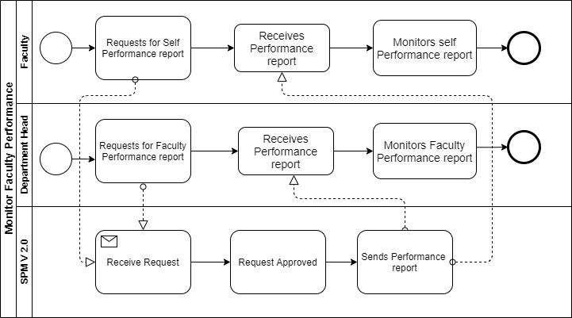

Figure 1.6: Monitor Faculty performance

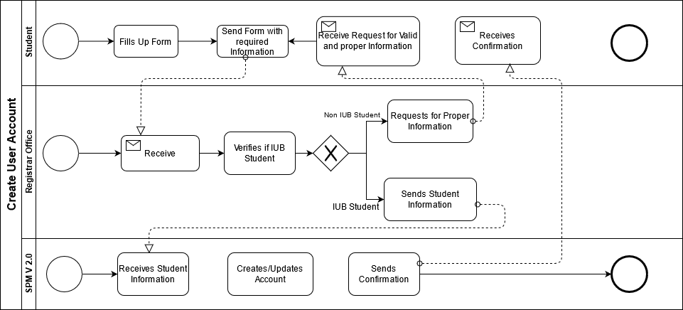

Figure 1.7: Creating user accounts.

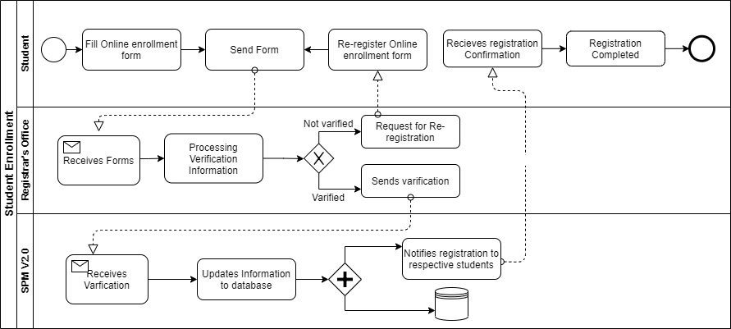

Figure 1.8: Student enrollment for registrations.

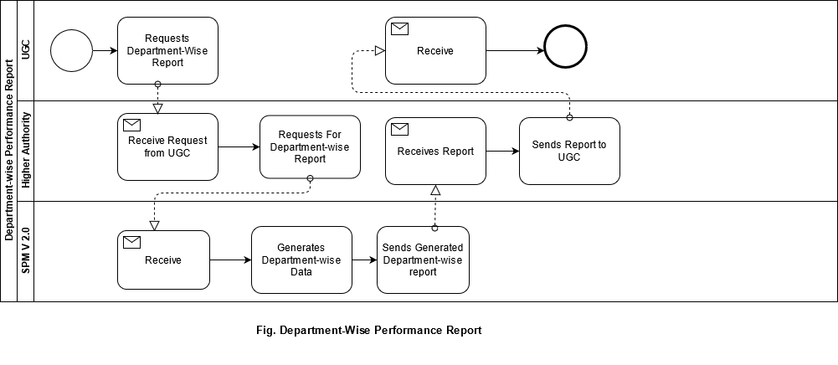

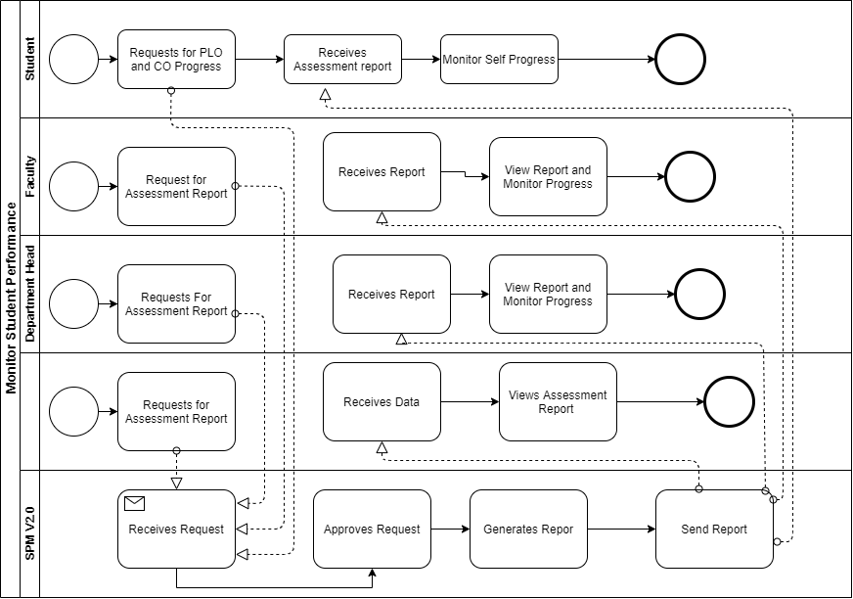

Figure 2.0: Monitor student performance

## **CHAPTER – 3 LOGICAL SYSTEM DESIGN**

## **A. BUSINESS RULE [ SPM V2.0 ]:**

This software can be used to ensure maximum efficiency in monitoring current students’ overall performance. The SPMV2 system is where all the PLO (Program Learning Outcome) and CO (Course Outcome) are stored. The CO is needed to be updated by the faculty for each course and before the semester starts to map the COs to the PLOs so that they can check if each student has achieved the required PLOs. IEB send PLOs requirement to the higher authority, Higher Authority forwards to SPMV2 admin and team who then updates the SPMV2 system database. The faculties can update the COs based on the given PLOs. The students can view their achieved PLOs for a particular course they've taken and see the required PLOs for the program in the system UGC & IEB have no authorization in monitoring the students’ performance so they have to request it through admin in order to view it.

**In the system, user would be provided with detailed information about:**

* School-wise, department-wise and program-wise student enrollment comparison.
* School-wise, department-wise and program-wise student performance trends based on CGPA with respect to a given period of time/semesters.
* School-wise, department-wise and program-wise student performance trends based on CGPA with respect to a given period of time/semesters.
* Course-wise (for a selection of courses) student performance trend based on GPA with respect to a given period of time/semesters.
* Instructor-wise (for a selection of instructors) student performance trend based on the GPA of the students in the courses taught by each of the instructors so far with respect to a given period of time/semesters.
* VC-wise, Dean-wise, or head-wise student performance trend based on the GPA of the students under the school/program corresponding to the leadership team.
* Instructor-wise student performance trend for a chosen course with respect to a given period of time/semesters.
* PLO total percentage score for each PLO calculated from the scores achieved in each CO associated with the corresponding PLO among all the courses the student has done so far, along with the departmental average performance for comparison. Also, for each PLO, what percentage of it was achieved from each of the courses associated with the corresponding PLO, and what percentage was achieved via each of all the COs associated with the corresponding PLO. All of this for a chosen school, program, or department.
* PLO achievement of a student for each of the courses taken so far.
* Comparison of PLO-achieved percentage versus PLO-attempted percentage
* Comparison of a course’s, student’s, department’s, program’s, or school’s expected PLO-achievement versus actual with respect to a given period of time/semesters.

.

Finally, a details analytical Summary of CO-PLO achievement stats for a chosen course, program, department, school will be provided to the user.

## **B. ENTITY RELATIONSHIP DIAGRAM:**

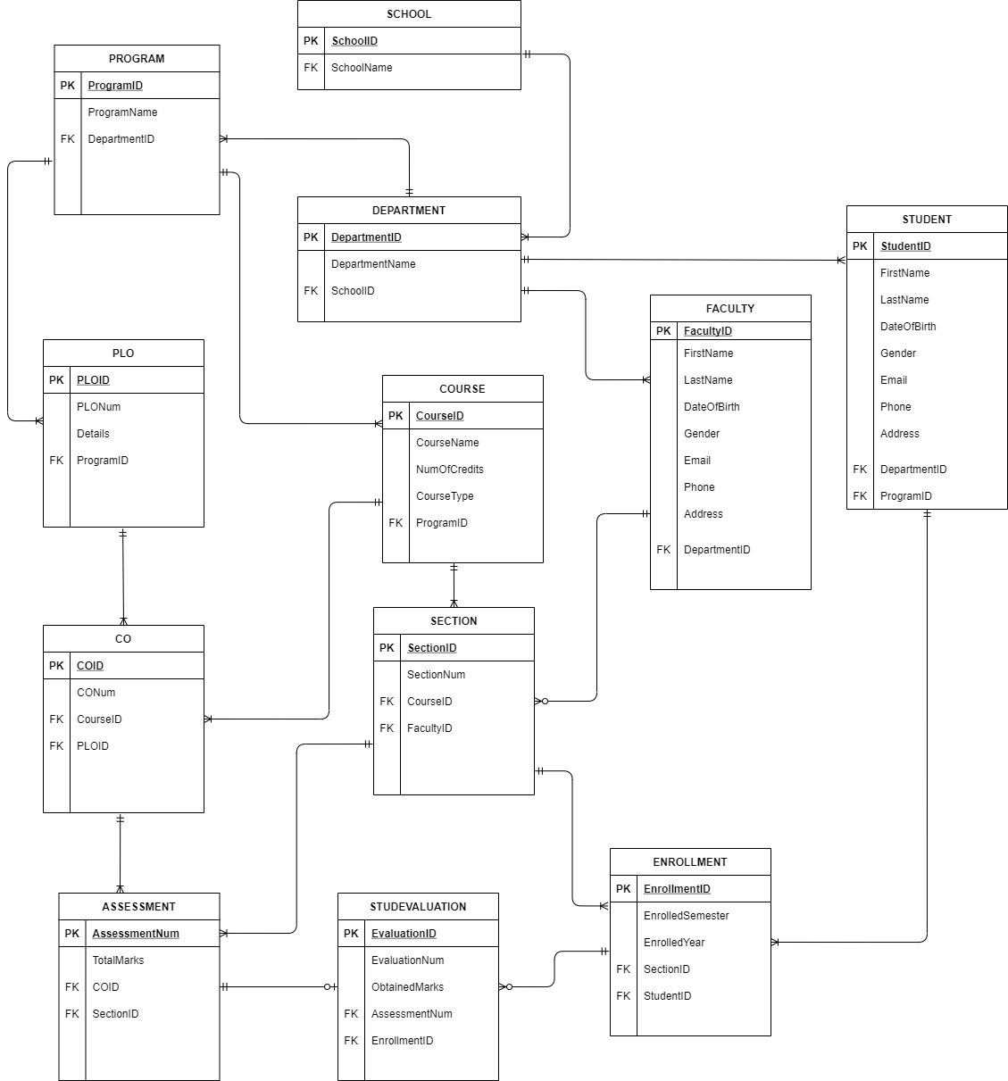

Figure: Entity relationship diagram

## **C. ENTITY RELATIONSHIP DIAGRAM TO RELATIONAL SCHEMA:**

## **D. NORMALIZATION:**

|  |  |  |  |  |  |
| --- | --- | --- | --- | --- | --- |
| Enrollment | EnrollmentID | e1 | Evaluation | EvaluationID | v1 |
| semester | e2 | evaluationNum | v2 |
| year | e3 | obtainedMarks | v3 |
| StudentID | t1 | assessmentNo | a1 |
| SectionID | q1 | EnrollmentID | e1 |
| Section | SectionID | q1 | Student | StudentID | t1 |
| sectionNo | q2 | FirstName | t2 |
| semester | q3 | LastName | t3 |
| CourseID | o1 | dateOfBirth | t4 |
| FacultyID | f1 | Gender | t5 |
| Course | CourseID | o1 | Email | t6 |
| courseName | o2 | Phone | t7 |
| noOfCredits | o3 | Address | t8 |
| courseType | o4 | DepartmentID | d1 |
| ProgramID | r1 | ProgramID | r1 |
| Program | ProgramID | r1 | Faculty | FacultyID | f1 |
| programName | r2 | FirstName | f2 |
| DepartmentID | d1 | LastName | f3 |
| Course | CourseID | o1 | Gender | f4 |
| CourseName | o2 | DateOfBirth | f5 |
| noOfCredits | o3 | Email | f6 |
| courseType | o4 | Phone | f7 |
| ProgramID | r1 | Address | f8 |
| School | SchoolID | s1 | DepartmentID | d1 |
| SchoolName | s2 | Assessment | assessmentNo | a1 |
| CO | COID | c1 | marksObtained | a2 |
| CONum | c2 | COID | c1 |
| PLOID | p1 | SectionID | q1 |
| CourseID | o1 | PLO | PLOID | p1 |
| Department | DepartmentID | d1 | PLONum | p2 |
| DepartmentName | d2 | details | p3 |
| SchoolID | s1 | ProgramID | r1 |

|  |  |
| --- | --- |
| s1➔ | s2 |
| d1➔ | d2, s1 |
| r1➔ | r2, d1 |
| f1➔ | f2, f3, f4, f5, f6, f7, f8, d1 |
| t1➔ | t2, t3, t4, t5, t6, t7, t8, r1, d1 |
| o1➔ | o2, o3, o4, r1 |
| p1➔ | p2, p3, r1 |
| c1➔ | c2, p1, o1 |
| q1➔ | q2, q3, o1, f1 |
| e1➔ | e2, e3, q1, t1 |
| a1➔ | a2, c1, q1 |
| v1➔ | v2, v3, a1, e1 |

|  |  |
| --- | --- |
| SchoolID➔ | SchoolName |
| DepartmentID➔ | DepartmentName, SchoolID |
| ProgramID➔ | programName, DepartmentID |
| FacultyID➔ | FirstName, LastName, gender, dateOfBirth, email, phone, address, DepartmentID |
| StudentID➔ | FirstName, LastName, dateOfBirth, gender, email, phone, address, DepartmentID, ProgramID |
| CourseID➔ | courseName, noOfCredits, courseType, ProgramID |
| ploID➔ | ploNo, details, ProgramID |
| coID➔ | courseName, PLOID, CourseID |
| SectionID➔ | sectionNo, semester, CourseID, FacultyID |
| EnrollmentID➔ | semester, year, SectionID, StudentID |
| assessmentNum➔ | marks, COID, SectionID |
| EvaluationID➔ | evaluationNum, marksObtained , assesmentNo, EnrollmentID |

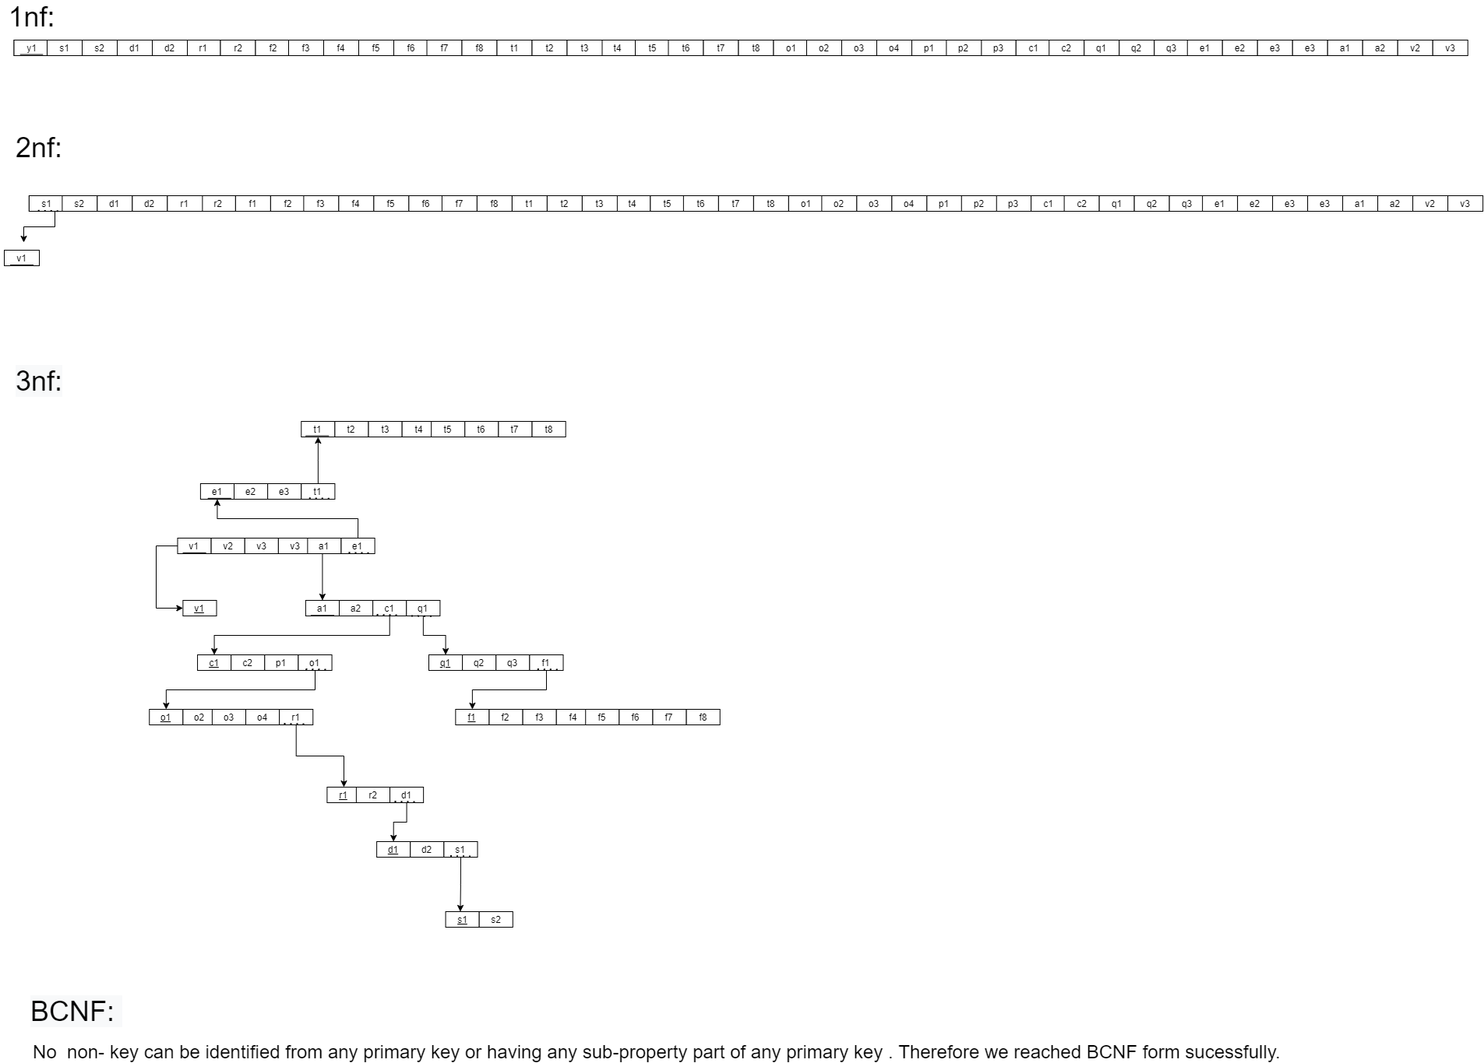

## **E. DATA DICTIONARY:**

School_T

|  |  |  |  |
| --- | --- | --- | --- |
| Name | Data Type | Size | Remarks |
| cSchoolID | VARCHAR | 5 | This is the primary key of School. E.g: “SETS” |
| cSchoolName | VARCHAR | 50 | This is the name of the School. E.g: “School of Engineering, Technology and Science”. |

Program_T

|  |  |  |  |
| --- | --- | --- | --- |
| Name | Data Type | Size | Remarks |
| cProgramID | VARCHAR | 5 | This is the primary key for a program. E.g:”B.Sc” |
| cProgramName | VARCHAR | 50 | This is the name of the program. E.g: “Bachelor of Science” |
| cDepartmentID | VARCHAR | 5 | This is the foreign key from the Department table. E.g: “CSE” |

Department_T

|  |  |  |  |
| --- | --- | --- | --- |
| Name | Data Type | Size | Remarks |
| cDepartmentID | VARCHAR | 5 | This is the primary key for the Department table. E.g: “CSE” |
| cDepartmentName | VARCHAR | 30 | This is the name of the department. E.g: “Computer Science and Engineering”. |
| cSchoolID | VARCHAR |  | This is a foreign key from the School table. E.g: “SETS”. |

Student_T

|  |  |  |  |
| --- | --- | --- | --- |
| Name | Data Type | Size | Remarks |
| cStudentID | CHAR | 7 | This is the primary key for the Student table. E.g: “1921834” |
| cFirstName | VARCHAR | 30 | This is the first name of the student.E.g:”Rakibul”. |
| cLastName | VARCHAR | 30 | This is the last name of the student. E.g: “Hasan” |
| dDateOfBirth | DATE | DD-MM-YYYY | This is the birth date of the student. E.g: “21-12-1996”. |
| cGender | VARCHAR | 7 | This is the gender of the student. |
| cEmail | VARCHAR | 30 | This is the email of the student. E.g: “1921834@iub.edu.bd” |
| cPhone | CHAR | 11 | This is the phone of the student. E.g: “01XXXXXXXXX” |
| cAddress | VARCHAR | 50 | This is the address of the student. E.g: “House 1,Road 4,Block D, Bashundhara RA |
| cDepartmentID | VARCHAR | 5 | This is the foreign key from the Department table. E.g: “CSE” |
| cProgramID | VARCHAR | 5 | This is the foreign key from the Program table. E.g: “B.Sc” |

CO_T

|  |  |  |  |
| --- | --- | --- | --- |
| Name | Data Type | Size | Remarks |
| cCOID | VARCHAR | 5 | This is the primary key for the CO table. E.g: “CO1” |
| nCONum | INTEGER |  | This is the CO number. E.g: 1,2 etc. |
| cCourseID | VARCHAR | 7 | This is the foreign key from the Course table. E.g: “CSE303” |
| cPLOID | VARCHAR | 5 | This is the foreign key from the PLO table. E.g: “PLO1” |

PLO_T

|  |  |  |  |
| --- | --- | --- | --- |
| Name | Datatype | Size | Remaks |
| cPLOID | VARCHAR | 5 | This is the primary key for Program Learning Outcome.  E.g:”PLO1” |
| cdetails | VARCHAR | 50 | This is the details for Program Learning Outcome.  E.g:”An ability to select and apply the knowledge, technique, skills and modern tools of the computer science and engineering discipline ” |
| cprogramID | VARCHAR | 50 | This is a foreign key from Program table  E.g: “B.SC” |
| cprogramID | VARCHAR |  |  |

F Faculty_T

|  |  |  |  |
| --- | --- | --- | --- |
| Name | Datatype | Size | Remaks |
| cfacultyID | VARCHAR | 4 | This is the primary key for Faculty  E.g:”1801” |
| cFirstName | VARCHAR | 30 | This is the first name of the faculty.  E.g:”Sadita” |
| cLastName | VARCHAR | 20 | This is the last name of faculty  E.g: “Ahmed” |
| ddateofbirth | DATE | DD-MM-YY | This is the date of Birth of the Faculty  E.g:01-01-1992 |
| cgender | VARCHAR | 7 | This is the gender of the faculty  Eg: “Female” |
| cemail | VARCHAR | 30 | This is the email address of the Student.  E.g: “1675231@iub.edu.bd” |
| cphone | VARCHAR | 15 | This is the phone number of the Faculty.  E.g: “01292383111” |
| caddress | VARCHAR | 30 | This is the address of the Faculty.  E.g: “House 14, Road 21, Sector 11, Baridara,  Dhaka, Bangladesh” |
| cdepartment_id | VARCHAR | 5 | This is the Foreign Key from the Department  table.  E.g: “CSE” |

Course_T

|  |  |  |  |
| --- | --- | --- | --- |
| Name | Datatype | Size | Remaks |
| ccourseID | VARCHAR | 7 | This is the Primary Key for the Course.  E.g: “CSE203” |
| ccourseName | VARCHAR | 40 | This is the name of the Course.  E.g: ”Discreet Maths ” |
| nnoOfCredits | INTEGER |  | This is the credit for the Course.  E.g: ”3” |
| ccourseType | VARCHAR | 10 | This is the type of the Course.  E.g: “Core” |

Section_T

|  |  |  |  |
| --- | --- | --- | --- |
| Name | Datatype | Size | Remaks |
| nSectionID | INTEGER |  | This is the Primary Key for Section |
| nsectionNo | INTEGER | 1 | This is the section number.  E.g: “1” |
| ccourse_id | VARCHAR | 7 | This is the foreign key from the Course  table.  E.g: “CSE101” |
| cfaculty_id | VARCHAR | 4 | This is the foreign key from Faculty table  E.g: “CO1” |
| csemester | VARCHAR | 6 |  |

Enrollment_T

|  |  |  |  |
| --- | --- | --- | --- |
| Name | Datatype | Size | Remaks |
| nenrollmentID | INTEGER |  | This is the Primary Key for Enrollment |
| csemester | VARCHAR | 6 | This is the semester of Enrollment  E.g: “Spring” |
| dyear | YEAR | yyyy | This is the year of Enrollment  E.g: “2018” |
| nsection_id | INTEGER |  | This is the Foreign Key from Section table” |
| cstudent_id | VARCHAR | 7 | This is the Foreign key from the Student Table.  E.g: “1800001” |

Assessment_T

|  |  |  |  |
| --- | --- | --- | --- |
| Name | Datatype | Size | Remaks |
| nassessmentNum | INTEGER |  | This is the Primary Key for Enrollment |
| cmarks | VARCHAR | 6 | This is the semester of Enrollment  E.g: “Summer” |
| dyear | YEAR | yyyy | This is the year of Enrollment  E.g: “2018” |
| nsectionID | INTEGER |  | This is the Foreign Key from Section table” |
| nCOID | INTEGER |  | This is the Foreign Key from the Course |